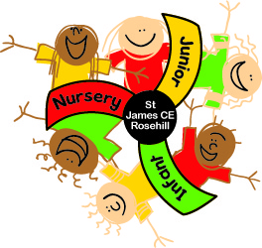
Nursery Curriculum News
Spring 1 2026

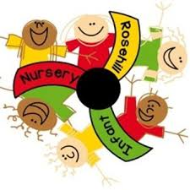

Happy New Year and welcome to Spring 1 - We hope you all had a wonderful and relaxing holiday. A big welcome to all the new children joining our nursery this term.

This half term our topic is Its Cold Outside.
Our focus to start the term will be snow and ice which is ideal with the weather at the moment. We will explore the winter season; appropriate clothing and we will make some soup to keep us warm. We will be learning about cold places around the world and the different animals that live in the cold climates.

LIBRARY BOOKS
The library is now in operation. Books will be swapped every Friday. If you want to swap the book at any time during the week you can still do so just talk to a member of staff.

Books and songs we will be focusing on this term:
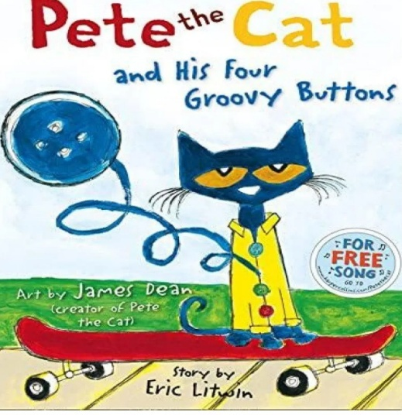
Below are some of the texts we will be covering.
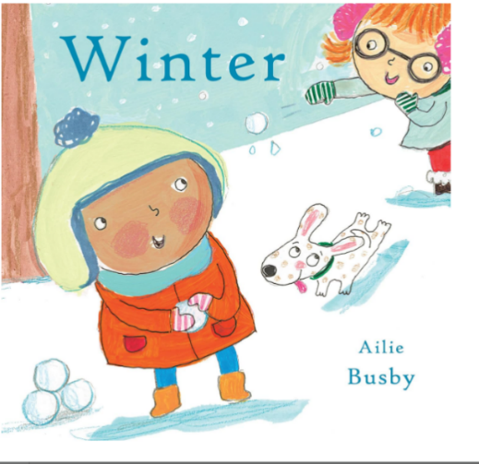
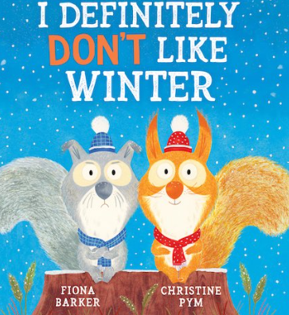

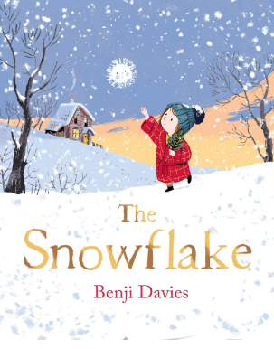
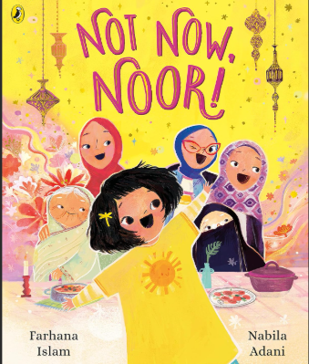

Nursery rhymes – Incy Wincy Spider, Twinkl twinkl little star,
Ways to Support your child’s learning at home
What can you see in Winter?
Practice counting to 5 and showing it on your hand.
How can you stay warm in Winter? How are you feeling?
What letter does your name start with? What sound does it make?
Can you sport a group of 2 and one? What does that make altogether? Shape hunt all around the house.
Ways to help at home
- Encourage your child to be independent: getting dressed, feeding, and toileting. This will have a big impact on their confidence and help with their fine motor, which will support their writing.
- Give your child lots of opportunity to draw
- Practise counting forward and counting out objects. Practise recognising numbers to 5
- Support your child to recognise and write their name. (Capital letter for the first letter of the name only)

Don’t forget we are always here to help.
We have an open-door policy

Snack money for this term is £6 payable online on Scopay
Many thanks Ms Manjoro

