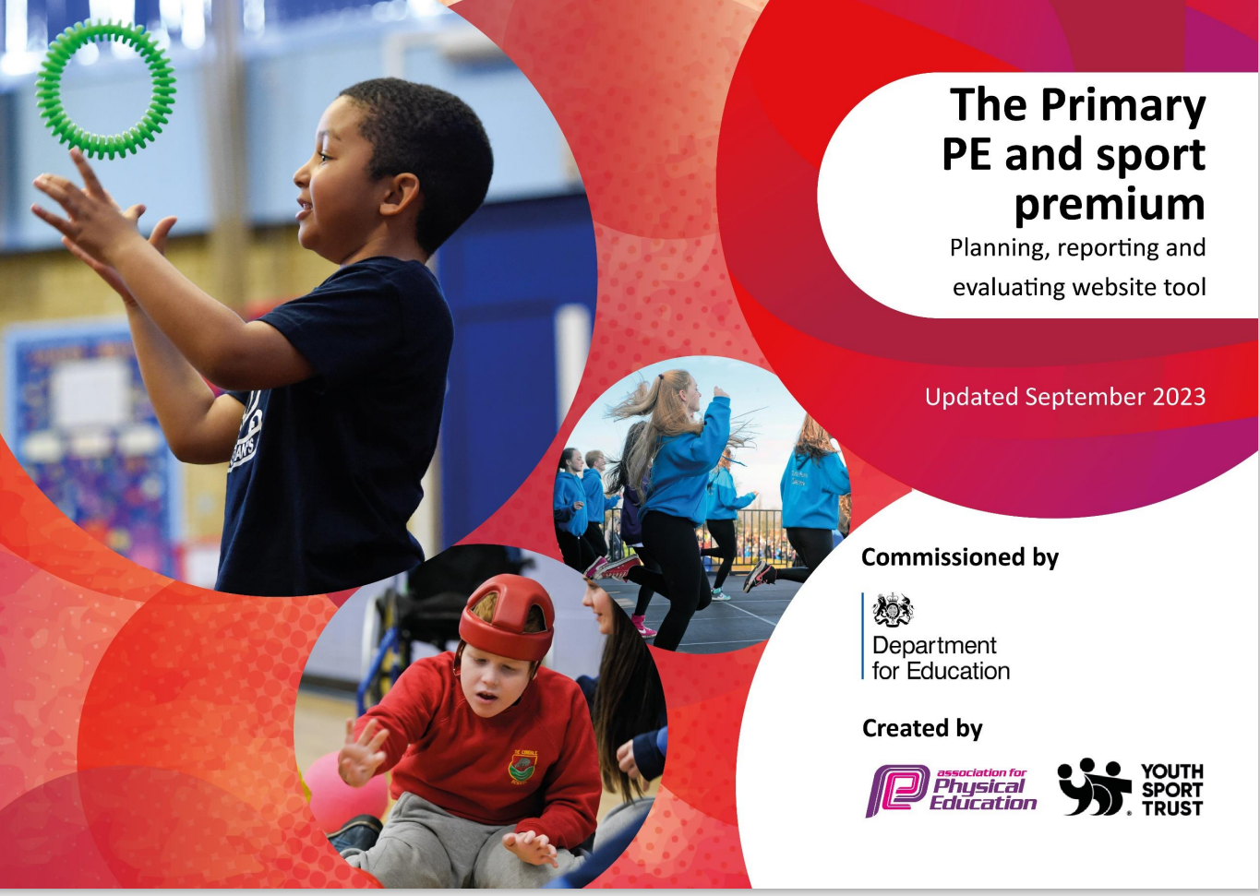

`
ROSEHILL INFANT SCHOOL SCHOOLS SPORTS FUNDING 2023 - 2024
Schools must use the funding to make additional and sustainable improvements to the quality of PE and sport they offer.
This means that you should use the Primary PE and Sport Premium to:
- develop or add to the PE and sport activities that your school already offers
- build capacity and capability within the school to ensure that improvements made now will benefit children joining the school in future years

Under the Ofsted Schools Inspection Framework, inspectors will assess how effectively leaders use the Primary PE and Sport Premium and measure its impact on outcomes for children, and how effectively governors hold them to account for this.

Schools are required to publish details of how they spend this funding as well as on the impact it has on children’ PE and sport participation and attainment.
We recommend regularly updating the table and publishing it on your website as evidence of your ongoing review into how you are using the money to secure maximum, sustainable impact.

Support for review and reflection - considering the 5 key indicators from DfE, what development needs are a priority for your setting and your students now and why? Use the space below to reflect on previous spend, identify current need and priorities for the future.

Physical Education, School Sport and Physical Activity / PESSPA
Key achievements to date: | Areas for further improvement and baseline evidence of need:
- the engagement of all children in regular physical activity  - Equipment is in place to enable children to be active at break and lunchtime  - We have 2 x 30minutes of PE curriculum time for KS1  - Children come to school in their PE kit to maximise learning time  - Reinforced the importance of Daily Physical Activity by using ‘wake and shake’ and Brain Brake activities everyday  - Rammie’s Daily Mile has been introduced to the whole  school, and is part of the lunchtime routine.  - Active lessons across the curriculum such as with the help of Teach Active Programme for Maths and English  - Multimedia purchased for the hall for self-evaluation and improvement as instant feedback can be given to individual children using iPads and large screen.  - Music facilities to improve the setting of the hall for dance and gym lessons.  - Yogabugs Impact and Change Programme for all EYFS2 children  - Boom Box purchased for use outside at lunchtime for DPA activities run by MDS  - the profile of PE and sport is raised across the school as a tool for whole-school improvement  Noticeboards in place displaying activities and information  - All staff have a PE kit to wear when teaching PE lessons.  - Regular section on the monthly school news letter  - Regular updates on Twitter, Dojo and Website  - National and local events shared with parents and families | - the engagement of all children in regular physical activity  - Continue to advocate the importance of Active Learning across the curriculum – provide cross curricular resources  - Generate a school ethos to promote “Good Physical Health = Good Mental Health” and vice versa.  - Engage more children in physical activity outside of school  - Promote to parents, activities they can take part in as a family together to encourage healthy, active lifestyles and wellbeing on school website  - Develop upper body and core strength, fine motor skills across the school – train new staff members in Physical Literacy  - Run a Physical Literacy Programme  - Implement an intervention for identified children with core strength needs  - Joint activities with older children to encourage physical activity during lunchtimes  - Forest School has a designated time allocation every week for all children  the profile of PE and sport is raised across the school as a tool for whole-school improvement  - Introduce half termly sports certificates– celebrate our attendance at festivals and competitions to a wider  audience  - Children to come into school wearing their PE kit on PE lesson days.  - Continue to promote our achievements on Social Media and display boards  - Familiarize parents with the importance of physical activity and its connection with mental wellbeing  - Purchase new PE shirts for new staff

- increased confidence, knowledge and skills of all staff in teaching PE and sport  - Every teacher has attended workshops and training, developing teachers knowledge and confidence  - Units of Work are in place for all PE lessons.  - TA’s fully trained in Physical Literacy and implement the  programme in KS1  - broader experience of a range of sports and activities offered to all children  - A range of after school clubs are on offer to children  - All year groups have the opportunity to attend sporting events and festivals enabling all children to take part (inclusive of SEN).  - Qualified Sports Coaches have run weekly multi-sport clubs – Muiti Skills, Football and Dance Support EYFS2 and KS1 Fine and Gross Motor skill programmes  - Annual Healthy Heart Week involving all children, staff and families with new sporting experiences, events and activities. | - increased confidence, knowledge and skills of all staff in teaching PE and sport  - Continue with CPD through annual staff audit of needs and requirements.  - More in-house support from PESSPA Leader  - Teacher training to develop Forest School across the school  - Online training for Yoga and Mindfulness  - Broader experience of a range of sports and activities offered to all children  - Continue to attend Derby SSP events with every child.  - Promote Forest School as an alternative outdoor activity  - Support wellbeing and mental health across the school with new equipment and activities  - Be part of National Fitness Day  - Take part in Bike to School Week  - Be part of National and local family activity initiatives

- increased participation in competitive sport  - Attending a variety of sporting events and competitions and festivals run by Derby City SSP (all year groups)..  - Annual Sports days  - Intra-school challenges  - Inter-school competitions | - increased participation in competitive sport  - Continue to embed intra-school competitions across all year groups  - Take part in Celebration of Dance  - Compete in KS1 Gymnastics Competition  - Participate in DCCT Roadshow

Action Plan and Budget Tracking
Capture your intended annual spend against the 5 key indicators. Clarify the success criteria and evidence of impact that you intend to measure to evaluate for students today and for the future.

Academic Year: 2023/2024 | Total fund allocated:  £17,090 | Date Updated: July 2024
Key indicator 1:  The engagement of all children in regular physical activity – Chief Medical Officer guidelines recommend that primary school children undertake at least 30 minutes of physical activity a day in school |  |  |  | Percentage of total allocation:
 |  |  |  | 37%
School focus with clarity on intended impact on children: | Actions to achieve: | Funding allocated:  £ 6,384 | Evidence and impact: | Sustainability and suggested next steps:
- Affiliate to Derby SSP | - Attend networks, festivals, competitions, training and workshops | SSP  Affiliation  £1750 | - Improved PESSPA delivery  - Developed teacher knowledge and understanding  - All children benefit from PESSPA | - Upskilled staff lead and plan more engaging active lessons across the curriculum  - School offers a wider range of opportunities to encourage 30+ daily active minutes
- Support short bursts of physical activity during lesson time to improve concentration and focus of children | - Share at staff meeting range of online resources | £0 | - More physical activity built into the school day for all children (Improved concentration reported by class teachers)  - Contributes to improved  attainment (SATs | - Staff equipped with knowledge and resources to continue to build in short bursts of physical activity.  - Continue to affiliate to SSP to access future workshops




 |  |  | results)
- DCCT roadshows in school to promote physical fitness and wellbeing and  encourage participation across the school. | - Engage every child with exciting opportunities to be physically active  - All 9 classes to take part in a roadshow | Included in SSP Affiliation Fee  (£1500 total) | - Children inspired and motivated to enjoy being more active. | - Continue to affiliate to SSP to attend other relevant festivals, giving more children the  opportunity to enjoy taking part
- Subscribe to Cosmic Kids to continue with yoga and mindfulness for all year groups | - Include the benefits of yoga and mindfulness while children have fun.  - Use stories and, role- play to make yoga and mindfulness fun.  - Encouraging children to move and stretch their bodies – while using breathing, relaxation and visualization techniques. | Yearly Subscription including online training for staff  £50.56 | - Children enjoy calming techniques  - Children gain confidence in their physical ability  - Children inspired and motivated to enjoy taking part in a non- threatening physical activity  - Staff trained in basic Yoga and Mindfulness techniques | - Continue to purchase the programme giving more children the opportunity to enjoy taking part and develop their skills.  - Develop the PE timetable to include relaxation techniques across all year groups.  - Staff confident to deliver Yoga and Mindfulness techniques

 |  |  | in physical activity
- All EYFS2 children have access to fine motor skill programmes | - Purchase resources for EYFS2 children to participate in regular activities to promote fine motor skills such as Dough Disco | Purchase resources such as play dough, scarves and ribbons for 3 classes approx. -  £100 | - Children are learning whilst being active  - Children gain confidence in their physical ability  - Children become stronger | - Continue with fine motor skill programmes to increase children’s physical ability and confidence
- All EYFS2 children have access to gross motor skill equipment | - Purchase resources for EYFS2 children to participate in regular activities to promote gross motor skills such as slides, scooters etc | Purchase resources for outdoor areas Approx. -  £500 | - Children are learning whilst being active  - Children gain confidence in their physical ability  - Children become stronger | - Continue with gross motor skill activities to increase children’s physical ability and confidence

- All KS1 children have access to fine motor skill activities to develop hand-eye coordination and dexterity for throwing and catching | - Purchase resources for children to participate in regular activities to promote fine motor skills such as funky fingers | Source resources to encourage fine motor skill  Approx. £100 | - Children are learning whilst being active  - Children gain confidence in their physical ability  - Children become stronger | - Continue with fine motor skill activities to increase children’s physical ability and confidence.
- Purchase equipment to develop core strength such as wheelie body boards – especially to help SEND needs | - Purchase resources for children to participate in regular activities to promote core strength | Source resources to encourage fine motor skill  Approx.  £1000 | - Children are learning whilst being active  - Children gain confidence in their physical ability  - Children become stronger | - Continue with gross motor skill activities to increase children’s physical ability and confidence.
Key Indicator 2:  The profile of PE and sport being raised across the school as a tool for the whole school improvement |  |  |  | Percentage of total allocation:
 |  |  |  | 5%
School focus with clarity on intended impact on  children: | Actions to achieve: | Funding allocated:  £900 | Evidence and impact: | Sustainability and suggested next steps:
- To attend the Super Schools Conference  - To attend SSP Breakfast Briefings  - Ensure school are up to date with key national and local developments in PE and Sport to ensure  children can benefit | - Attend SSP Breakfast Briefings and Conference  - Share information from SSP e-bulletin  - Sign up to national programmes (e.g. Primary Stars, Super Movers) to provide new opportunities for children | Included in SSP  Affiliation Fee (£1500 total)  AR/HK  15/09/23 | - School is benefitting from national and local strategies and enabling more children to be more active, more often (feedback)  - Accounts are activated and | - Continue to sign up to national and regional programmes that promote sport and activity  - Continue to affiliate to Derby City SSP

from high quality PE and Sport provision |  | Supply costs up to 3 days @£200 per day  LB 2024 tbc Briefing ½ day  Total £700 | national programmes are utilised
- SSP Termly Report  - Share SSP Termly Report to demonstrate the value school places upon PE, Sport and Physical Activity for the children and to celebrate our success/ participation | - Share termly report with Senior Leaders and Governors  - Share termly report on school website  Review termly reports to continue to build upon success/ participation | Included in SSP  Affiliation Fee (£1500 total) | - Good level of uptake of opportunities (termly report)  - More children accessing a range of opportunities and benefitting from high quality PE lessons (termly report) | - Use report data to inform future planning/ areas for development  - Continue to affiliate to SSP for future reports
- Maintain and repair existing large PE apparatus | - Yearly safety inspection | Dec/Jan  £200 | - Equipment  maintained to a high standard | - Children respect equipment and use thoughtfully

Key indicator 3:  Increased confidence, knowledge and skills of all staff in teaching PE and sport |  |  |  | Percentage of total allocation:
 |  |  |  | 7.5%
School focus with clarity on intended  impact on children: | Actions to achieve: | Funding  allocated:  £1,300 | Evidence and impact: | Sustainability and suggested  next steps:
- PESSPA Leader to team teach and observe | - Audit staff for training needs.  - Arrange times to team teach, observe or be observed with other staff | Supply cover for PESSPA lead  Two days supply @£200 per day | - Staff have the knowledge, skills and confidence to deliver PE | - School is no longer dependent on coaches coming in to teach PE & Sport – PESSPA Lead offers more in-house support
- PESSPA lead management time – update resources, planning, policies and organize events | - Audits of equipment  - Organize events  - Co-ordinate with outside agencies  - Update planning and policies  - Work with HLTA | Supple cover for PESSPA lead  2 days supply @£200 per day | - School stays up to date with national standards  - Children participate in regular new activities  - Children have good quality resources | - Continue to affiliate to Derby City SSP to remain up to date with national and local strategies  - Sign up to new national programmes to continue to develop our opportunities  - Revisit policies to ensure they are still fit for purpose and link with whole school plan
- PE Training Workshops  - Support all teaching staff | - Book training place(s) via SSP | Included in SSP | - Staff have the knowledge, skills and | - Staff are confident  and competent to deliver PE

through access to ongoing training to equip them with the knowledge, skills and confidence to teach high quality PE | - Meet with staff following training to offer further support  - Organise team teaching to share good practice at staff meeting | Affiliation Fee  (£1500 total)  Up to 3 days supply cover @£200 per day cover | confidence to deliver PE (professional development files) | - School is no longer dependent on coaches coming in to teach PE & Sport – PESSPA Lead offers more in-house support  - Continue to affiliate to Derby City SSP to access further CPD
- EYFS CPD | - Book two TAs onto one day training provided by SSP | Supply for 2 TA  £200 15/03/24 | - ​
- Physical Literacy Training | - Book TA and PE Lead onto one day training provided by SSP | Supply for 2 TAs  £100 26/10/23 AR | - Staff have the knowledge, skills and confidence to deliver Physical Literacy Programme | - Staff are confident and competent to deliver programme across the school.  - Every TA trained
Key indicator 4:  Broader experience of a range of sports and activities offered to all children |  |  |  | Percentage of total allocation:
 |  |  |  | 15%
School focus with clarity on intended  impact on children: | Actions to achieve: | Funding  allocated:  £9,000 | Evidence and impact: | Sustainability and suggested  next steps:
Source, purchase and a mobile trim trail and lazy Lawn | - Explore trim Trail options  - Obtain quotes  - Install on new items | £7,000 | - Children experience different physical activity options  - Increased core strength | - Children inspired and motivated to take part  - Learn to act responsibly when handling the equipment
- Purchase good quality equipment  - Purchase additional equipment for MDS to  enhance lunchtime | - Audit small apparatus and mats  - Find suitable replacement items  - Purchase required | £200 | - Children work with quality resources which reflect the importance of the activity taking  place. | - Children inspired and motivated to take part  - Learn to act responsibly when

Activity | resources |  |  | handling the equipment
- Free access to OSH clubs | - Allocate day/time for OSH club  - Identify eligible children  - Identify cost | Pupil Premium children offered free places - £4 per session/ per child Upto £500 | - Running additional clubs for more children to access  - Supporting least active children through targeted activities  - Increase opportunities to be physically active | - Use children as role models to encourage inactive children to be active  - Identify places in clubs
- Healthy Heart Week | - Set date  - Book new and exciting physical activities to try  - Arrange for nutritionist to give food demonstrations and participation events  - Purchase resources i.e. fresh fruit etc.  - Support staff  - Share information with parents | Allocate £50 per class to use during the week on a new healthy activity (£300 total) | - All children experience new activities  - Profile of PESSPA increased  - Parents involved  - New foods tried  - The profile of Mental health is raised | - Children and parents gain more information about healthy lives to continue at home  - More children get active and join new clubs outside of school
Key indicator 5:  Increased participation in competitive sport |  |  |  | Percentage of total  allocation:
 |  |  |  | 5.5%
School focus with clarity on intended  impact on children: | Actions to achieve: | Funding  allocated:  £950 | Evidence and impact: | Sustainability and suggested  next steps:
- Intra-sport festivals  - Lead intra-competition challenges to encourage children to enjoy taking part in school based competitions | - Liaise with SSP to plan intra-competition programme and gain ideas  - Look at Virtual Challenges  - Identify staff to deliver/ support competitions  - Arrange dates for competitions  - Celebrate participation | Included in SSP  Affiliation Fee  (£1500 total) | - Termly intra-competition programme in place with all of children taking part  - Participation celebrated at assembly  - Children inspired and motivated to take part (feedback) | - Offer further intra- competition challenges

- Intra school challenges | - Organize events and equipment  - Organize whole school teams  - Support staff | Supply Cover for PESSPA Lead  £200 | - Increases participation in competitive sport  - Enables more children to access and enjoy taking part in competition | - Gives children the opportunity to enjoy being active.
- Sports Day | - Organize events and equipment  - Organize whole school teams  - Support staff  - Coordinate with Young Sports Leaders  - Share information with parents  - Purchase rewards | Supply Cover for PESSPA Lead  £200  Medals, ribbons and certificated  £150 | - Increases participation in competitive sport  - Enables more children to access and enjoy taking part in competition | - Gives children the opportunity to enjoy being active.

