What can families do to help our school achieve this award?  - Read our newsletters and information sent out.  - Come along to events we organise if you are able  - Complete any questionnaires we send out as honestly as  - you can  - Take a look at our website for updates and latest news/events.  - Let us know of any improvements you think we can make  - in our communications to you.  Who can I talk to if I’d like more information about this award?  Please call in at the office with any questions you may have  about our work in achieving this award.  We hope to achieve the award during this academic year and  we will keep you informed about our progress in newsletters  and our website. We look forward to seeing you at our family  events. | 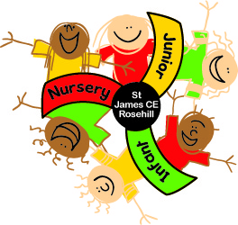  LEADING PARENT PARTNERSHIP AWARD  AT  ROSEHILL NURSERY AND INFANT SCHOOL  Rosehill Nursery and Infant School has recently signed up to the Leading Parent Partnership Award.  What is the Leading Parent Partnership Award?  (LPPA)  The LPPA is a nationally recognised award achievable by schools who work very closely with the families of their pupils.  What does the school have to do to achieve the award?  The award has 10 different objectives that the school has to achieve (see overleaf).  An external advisor carries out an assessment and if the school shows it meets these 10 objectives then the award is granted.

The school demonstrates a commitment to work towards the Leading Parent Partnership Award.
The school provides parents with relevant and user friendly guidance and information to help them support their children’s learning.
The school promotes an awareness of and participation in lifelong learning opportunities available in school and in the community to all groups and parents.
The school evaluates performance against the Leading Parent Partnership Award.
The school provides good support for transition for parents when their children leave the school.
The school produces and implements parent friendly policies to establish effective home school-links and improve pupil/student attendance, punctuality, behaviour and progress and positive participation in school.
The school is a welcoming and friendly place for parents.
The school provides good induction for all new parents.
The school makes and implements effective plans to achieve and maintain the Leading Parent Partnership Award.
The school holds and actively promotes enrichment opportunities or events for joint parent/child participation.

