Communication and Language
Birth to three  - Understand single words in context – ‘cup’, ‘milk’, ‘daddy’.  - Understand frequently used words such as ‘all gone’, ‘no’ and ‘bye-bye’.  - Understand simple instructions like “give to mummy” or “stop”.  - Recognise and point to objects if asked about them.  - Generally focus on an activity of their own choice.  - Listen to other people’s talk with interest.  - Start to say how they are feeling, using words as well as actions.  - Start to develop conversation, often jumping from topic to topic.  - Develop pretend play: ‘putting the baby to sleep’ or ‘driving the car to the shops’  - Listen to simple stories and understand what is happening, with the help of the pictures.  - Identify familiar objects and properties for practitioners when they are described. For example: ‘Katie’s coat’, ‘blue car’, ‘shiny apple’. Understand and act on longer sentences like ‘make teddy jump’ or ‘find your coat’.  - Understand simple questions about ‘who’, ‘what’ and ‘where’ (but generally not ‘why’) |  |  | 3 and 4 year olds  - Enjoy listening to longer stories and can remember much of what happens.  - Pay attention to more than one thing at a time.  - Use a wider range of vocabulary.  - Understand a question or instruction that has two parts, such as “Get your coat and wait at the door”.  - Understand ‘why’ questions, like: “Why do you think the caterpillar got so fat?”  - Sing a large repertoire of songs, know many rhymes, be able to talk about familiar books, and be able to tell a long story.  - Develop their communication and use longer sentences of four to six words.  - Be able to express a point of view and to debate when they disagree with an adult or a friend, using words as well as actions. • Can start a conversation with an adult or a friend and continue it for many turns.  - Use talk to organise themselves and their play: “Let’s go on a bus... you sit there... I’ll be the driver.”
Possible activities in order to achieve progression of skills objectives for Autumn 1
Taught Session  Daily phonics following twinkl phonics scheme.  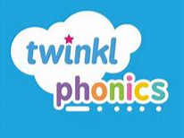 | Taught Session  Daily story time with speaking and listening opportunities within small group. (links to Literacy)  Core books and nursery rhymes linked to topic chosen for this half term | Taught Session  Daily singing of familiar nursery rhymes and also specific rhymes linked to topic. (links to music)  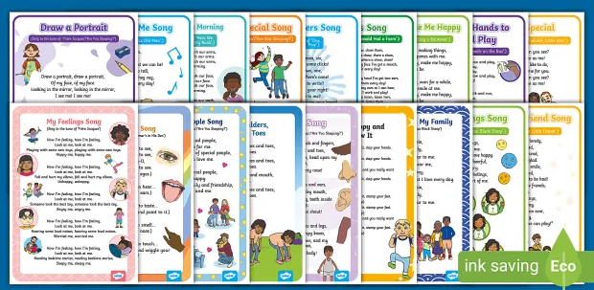 | Taught Session  Weekly topic focus for discussion.  Week 1 – My House  Week 2 – My Family  Week 3 – My local area  Week 4 - Pets  Week 5 – Things I like to do  Week 6 – All About Me | Taught in provision  Language rich environment.  Staff continually modelling language. | Taught in provision  All areas set up to encourage children to play and interact with each other.
Parent Engagement
Parents invited to attend a story time session. Model to them how build vocabulary around a book.
Singing session with parents.
Library sessions to give children access to a new book at home weekly.
Provision Enhancements
All areas set up to promote communication and collaborative play and learning.
Books in the home corner chosen as they are popular texts that the children may have come across before and that will encourage them to talk about it. Others topic related or with a specific character the children may recognise.
Develop an area linked to emotions and feelings.
Communication and language

Personal, Social, Emotional Development

Personal, Social, Emotional Development (PSHE, C&L)
Birth to three  - Find ways to calm themselves, through being calmed and comforted by their key person.  - Establish their sense of self.  - Express preferences and decisions. They also try new things and start establishing their autonomy.  - Engage with others through gestures, gaze and talk.  - Use that engagement to achieve a goal. For example, gesture towards their cup to say they want a drink.  - Find ways of managing transitions, for example from their parent to their key person.  - Thrive as they develop self-assurance.  - Look back as they crawl or walk away from their key person. Look for clues about how to respond to something interesting.  - Play with increasing confidence on their own and with other children, because they know their key person is nearby and available.  - Feel confident when taken out around the local neighbourhood, and enjoy exploring new places with their key person.  - Feel strong enough to express a range of emotions.  - Grow in independence, rejecting help (“me do it”). Sometimes this leads to feelings of frustration and tantrums.  - Begin to show ‘effortful control’. For example, waiting for a turn and resisting the strong impulse to grab what they want or push their way to the front.  - Be increasingly able to talk about and manage their emotions.  - Notice and ask questions about differences, such as skin colour, types of hair, gender, special needs and disabilities, and so on.  - Develop friendships with other children.  - Safely explore emotions beyond their normal range through play and stories.  - Talk about their feelings in more elaborated ways: “I’m sad because...” or “I love it when ...”.  - Learn to use the toilet with help, and then independently. |  |  |  | 3 and 4 year olds  - Select and use activities and resources, with help when needed. This helps them to achieve a goal they have chosen, or one which is suggested to them.  - Develop their sense of responsibility and membership of a community.  - Become more outgoing with unfamiliar people, in the safe context of their setting.  - Show more confidence in new social situations.  - Play with one or more other children, extending and elaborating play ideas.  - Find solutions to conflicts and rivalries. For example, accepting that not everyone can be Spider-Man in the game, and suggesting other ideas.  - Increasingly follow rules, understanding why they are important.  - Remember rules without needing an adult to remind them.  - Develop appropriate ways of being assertive.  - Talk with others to solve conflicts.  - Talk about their feelings using words like ‘happy’, ‘sad’, ‘angry’ or ‘worried’.  - Understand gradually how others might be feeling.  - Be increasingly independent in meeting their own care needs, e.g. brushing teeth, using the toilet, washing and drying their hands thoroughly.  Make healthy choices about food, drink, activity and tooth brushing.
Possible activities in order to achieve progression of skills objectives for Autumn 1
Taught Session  Friendship cafe | Taught Session  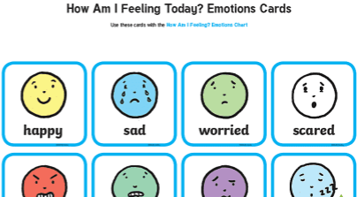  feeling | Taught Session  Talk about their community – who do they live with? | Taught in provision  Following rules and routines.  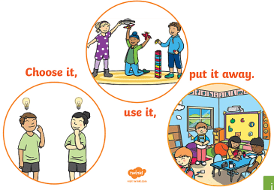 |  | Taught in provision  Children given choices | Taught in provision  Morning routine
Parent Engagement
Parents asked to support their child in morning routine, self registration and name writing. This familiar routine will help the children quickly settle and be able to separate from their parents happily.
Dojo information given to parents about the importance of labelling feelings and talking about feelings.
Provision Enhancements
Friendship café.
Develop an area linked to emotions and feelings.

Physical Development
Physical Development
Birth to three  Autumn  - Gradually gain control of their whole body through continual practice of large movements, such as waving, kicking, rolling, crawling and walking.  - Clap and stamp to music.  - Fit themselves into spaces, like tunnels, dens and large boxes, and move around in them. (links to Maths)  - Build independently with a range of appropriate resources. (links to Maths)  - Show an increasing desire to be independent, such as wanting to feed themselves and dress or undress. |  |  |  | 3 and 4 year olds  Autumn  - Use large-muscle movements to wave flags and streamers, paint and make marks.  - Increasingly be able to use and remember sequences and patterns of movements which are related to music and rhythm.  - Use one-handed tools and equipment, for example, making snips in paper with scissors.  - Use a comfortable grip with good control when holding pens and pencils.
Taught session and Taught in provision  Week 1 - Focus on Lying, propping and rolling  Week 2 - Focus on crawling  Week 3 - Focus on sitting postures on the floor and kneeling.  Week 4 - Focus on balancing, standing, walking and running.  Week 5 - Focus on Jumping, hopping and skipping  Week 6 - Focus on climbing, hanging, pushing, pulling and swinging. | Taught session  Daily physical literacy using streamers and flags to develop large muscle movement.  Daily dance routine that children are increasingly able to remember. | Taught session  Daily dough disco   | Taught in provision  Children encouraged to use the toilet independently. | Taught in provision  Children encouraged to access and feed themselves snack independently. | Taught in provision  Variety of different construction toys to encourage children to build independently. | Taught in provision  Variety of one handed tools and writing opportunities available through the classroom.  Large-scale painting. | Taught in provision  Fine motor skills activities on tough spot and also incorporated into all other areas.
Parent Engagement
Physical development focus of the week displayed of parents notice board.
Parents encouraged to get their children out of nappies in the first half term.
Modelled dough disco and physical literacy session to parents.
Provision Enhancements
Scarves to dance with.
Hidey holes outside.
Activities set out to target physical development focus of the week.

Literacy
Literacy (some taken from communication and language, links with physical development)
Birth to three  Autumn  - Enjoy songs and rhymes, tuning in and paying attention.  - Enjoy sharing books with an adult.  - Pay attention and respond to the pictures or the words.  - Enjoy drawing freely.  - Listen and respond to a simple instruction.  - Copy your gestures and words.  - Use intonation, pitch and changing volume when ‘talking’.  - Recognise and point to objects if asked about them.  - Understand simple instructions  - Listen to other people’s talk with interest, but can easily be distracted by other things.  - Make themselves understood, and can become frustrated when they cannot.  - Develop pretend play: ‘putting the baby to sleep’ or ‘driving the car to the shops’. |  |  | 3 and 4 year olds  Autumn  - Consolidation of all birth to 3.  - Write some or all of their name.  - Understand the five key concepts about print:  - print has meaning - print can have different purposes  - we read English text from left to right and  - from top to bottom  - the names of the different parts of a book  - page sequencing  - Pay attention to more than one thing at a time, which can be difficult.  - Use longer sentences of four to six words.
Week 1 – My House  Focus Text – In every house on Every Street  Drawing a house  Building a house (EAD links)  Small world house (EAD links)  Looking at pictures of different houses  Lolly pop stick houses (maths links)  Making houses in craft area (EAD links)  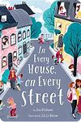 | Week 2 – My Family  Focus Text – Our class is a family  Family picture (links to EAD)  Name games  Class rules (PSED links)  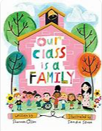 | Week 3 – My Local Area  C&L focus  Looking at pictures of the local area (geography links)  Drawing buildings of significance (links to EAD)  Visit to the library | Week 4 – Pets  Focus Text – Hello world, Pets  Do you have any pets?  What animals can you have as pets?  Meet the guinea pigs  If you could have a pet, what would it be?  Drawing pets. (links to EAD)  Making pets out of different shapes. (links to maths and EAD)  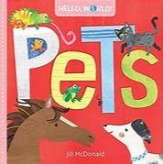 | Week 5 – Things I like to Do  C&L Focus  Talk about things you like to do.  Share photos of some things children do outside of school.  What are you good at? | Week 6 – All About Me  Focus Text – Everybody has a body.  Self portraits (links to EAD)  Labelling body parts  Head shoulders knees and toes.  Feelings  What do you like to eat?  Name games  My 5 senses (links to science and EAD)  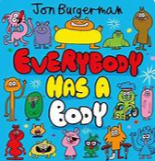
Parent Engagement
Parents to accompany the children to the library
Nursery library set up so children can borrow a new book weekly.
Singing session with parents.
Modelled story time.

Phonics
Aspect 1 General Sound Discrimination – Environmental Sounds  • Develop listening skills and awareness of sounds in the environment  • Identify and remember the differences between sounds  • Talk about sounds in greater detail  Aspect 2 General Sound Discrimination – Instrumental Sounds  • Develop awareness of sounds made with instruments  • Listen to and appreciate the difference between sounds made with instruments  • Use a wide vocabulary to talk about instrument sounds  Aspect 3 Body Percussion  • Develop awareness of sounds and rhythms  • Distinguish between sounds and remember patterns of sound  • Talk about sounds we make with our bodies and what the sounds mean  Aspect 4 Rhythm and Rhyme  • Experience and appreciate rhythm and rhyme  • Develop awareness of rhythm and rhyme in speech  • Increase awareness of words that rhyme and develop knowledge about rhyme  • Talk about words that rhyme and produce rhyming words |  |  |  | Aspect 5 Alliteration  • Develop understanding of alliteration  • Listen to sounds at the beginning of words and hear the differences between them  • Explore how different sounds are articulated  Aspect 6 Voice Sounds  • Distinguish between the differences in vocal sounds  • Explore speech sounds  • Talk about the different sounds that we can make with our voices  Aspect 7 Oral Blending and Segmenting  • Develop oral blending and segmenting of sounds in words  • Listen to sounds within words and remember them in the order in which they occur  • Talk about the different sounds that make up words
Week 1 (12th Sept) – My House  Large Group Activity:  Sleepy Sofa Sounds – Aspect 1  Sounds Around the House – Aspect 6  Crash the Truck Has a Box – Aspect 1  Ted’s Footsteps – Aspect 2  Happy Sounds – Aspect 3  Small Group Activity:  Let’s Shake – Aspect 2  Bubbles in the Bath – Aspect 3  Pyjama Palaver – Aspect 5  Silly Socks – Aspect 5  Rabbit Rock and Roll – Aspect 4 | Week 2 (19th Sept) – My Family  Large Group Activity:  Family Footsteps – Aspect 2  Listen to My Family – Aspect 1  Things We Do – Aspect 3  Family Chatter – Aspect 6  A Family Walk – Aspect 4  Small Group Activity:  Sound Bingo – Aspect 1  Auntie's Awful Soup – Aspect 5  My Noisy Family – Aspect 1  My Musical Family – Aspect 2  Trip to the Shops – Aspect 5 | Week 3 (26th Sept) – My Local Area  Large Group Activity:  What Do You Hear? – Aspect 1  Sounds Where I Live – Aspect 4  The Pied Piper – Aspect 3  Corners of My Town – Aspect 5  At the Bus Stop – Aspect 1  Small Group Activity:  Drum Sounds – Aspect 2  I Heard... – Aspect 1  What Can I Find? – Aspect 5  Local Rhymes – Aspect 4  Sound Trumpets – Aspect 6 | Week 4 (3rd October) – Pets  Large Group Activity:  Pet Sounds – Aspect 6  Which Pet? – Aspect 2  Keep the Beat – Aspect 3  Clog the Dog – Aspect 4  The Pet Shop – Aspect 5  Small Group Activity:  Rhyming Pairs – Aspect 4  Guess the Pet – Aspect 1  Pets at the Vet's – Aspect 5  Musical Pets – Aspect 2  Pet Movements – Aspect 3 |  | Week 5 (10th October) – Things I like to Do  Large Group Activity:  Who's Under There? – Aspect 6  Move and Groove – Aspect 3  I Like to Dance – Aspect 2  Funny Sounds – Aspect 6  Missing Rhyme – Aspect 4  Small Group Activity:  Loud or Quiet? – Aspect 1  Little Drummers – Aspect 2  Copy Me – Aspect 3  I Like to Explore – Aspect 1  Dana Dinosaur's Word Walk – Aspect 5 | Week 6 (17th October) – All About Me  Large Group Activity:  I Like Being Me 4  I Am Happy 4  My Body 4  My Name Is 5  How are You Feeling Today? 2  Small Group Activity:  My Listening Ears 1  My Sound 2  My Noisy Feet 3  Silly Mouth Dance 6  What I like to Eat 6
Parent Engagement
Dojo information about phonics and why we do it
Phase 1 phonics meeting for parents.
Provision Enhancements
Musical instruments.
Sound books to listen to.
Alphabet
Children encouraged to talk about sounds and the sounds in words/their name.

Maths
Number:  - Knows that things exist, even when out of sight. (happening all the time through teaching and in provision)  - Beginning to organise and categorise objects, e.g. putting all the teddy bears together or teddies and cars in separate piles.  - Says some counting words randomly.  - Combine objects like stacking blocks and cups. Put objects inside others and take them out again. (happening all the time through teaching and in provision)  - Take part in finger rhymes with numbers.  - React to changes of amount in a group of up to three items.  Autumn 1 – Colour of the week (focus on sorting, children still settling)  1 Red  2 Blue  3 Green  4 Yellow  5 Purple  6 Orange |  |  |  | Shape, space and measure –  There is no specific ELG related to this unit. This unit supports the Development Matters statement Select, rotate and manipulate shapes in order to develop spatial reasoning.  - Climb and squeezing selves into different types of spaces. (happening all the time through teaching and in provision – Outside focus)  - Build with a range of resources. (happening all the time through teaching and in provision – construction area, Expressive arts and design)  - Attempts, sometimes successfully, to fit shapes into spaces on inset boards or jigsaw puzzles. (Puzzles and shape sorters in continuous provision)  - Uses blocks to create their own simple structures and arrangements (happening all the time through teaching and in provision – construction area, Expressive arts and design. Will buy magnetic tiles)  - Enjoys filling and emptying containers. (happening all the time through teaching and in provision – sand and water – Taught session on full and empty)  Beginning to understand that things might happen ‘now’. (happening all the time through teaching and in provision)  Autumn 2 – Number of the week – focus on Number Songs  1 – Focus on number 1  2 - Focus on number 2  3 - Focus on number 3  4 - Focus on number 4  5 - Focus on number 5  6 – number songs to 5  7 – Christmas number songs for performance  - 8 - Christmas number songs for performance
Taught session  Colour hunt  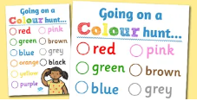 | Taught session and Taught in provision  Sorting objects by colour  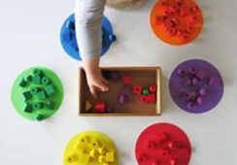 | Taught session and Taught in provision  Sorting objects in other ways  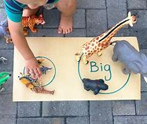 | Taught session and Taught in provision  Counting how many of each colour we have found. |  | Taught session and Taught in provision  Number rhymes  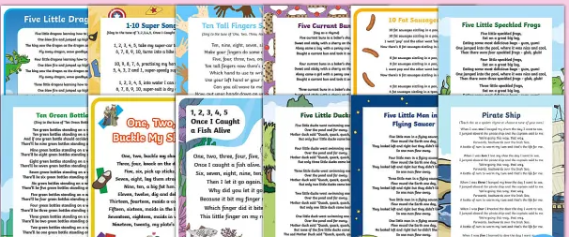 | Taught session and Taught in provision (links to EAD)  Mixing colours  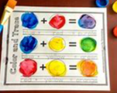 | Taught session and Taught in provision (links to EAD)  Colour shades
Maths
Parent Engagement
Colour of the week displayed on parents board.
Maths in early years information fed through dojo.
Provision Enhancements
Sorting by colour
Different coloured paints
Different coloured pens/pencils
Colour display posters
Understanding the world
Science
- Use all their senses in hands-on exploration of natural materials.  - Explore collections of materials with similar and/or different properties.  - Talk about what they see, using a wide vocabulary  - Plant seeds and care for growing plants.  - Understand the key features of the life cycle of a plant and an animal.  - Begin to understand the need to respect and care for the natural  environment and all living things  - Explore and talk about different forces they can feel.  - Talk about the differences between materials and changes  they notice. |  |  |  | Animals, including humans  - Begin to recognise and identify the main parts of the body (human link).  - opportunities to explore the 5 senses through practical sensory activities  - begin to understand the importance of looking after themselves through good everyday hygiene  - Eating healthy snacks and talk about importance of a healthy diet.  - Name healthy snacks and fruits that are shared at snack time  - Talk about ways to keep healthy and safe.
Possible activities in order to achieve progression of skills objectives for Autumn 1
Taught session (links to geography and EAD)  Planting – cress heads  Links to body parts.  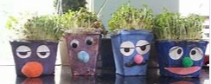 | Taught session (links to geography)  Week 4 guinea pigs to visit – talk about looking after animals. What the guinea pigs need. Labeling different parts of guinea pigs body. | Taught session  Labeling the parts of human body.  Singing head, shoulders knees and toes. | Taught session (links to EAD)  5 senses children to cut and stick to make a picture showing 5 senses. Will add pec pictures to labels to support.  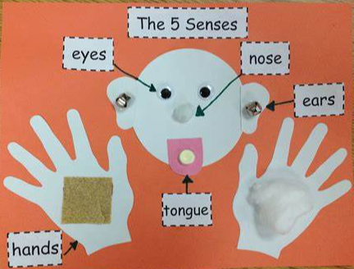 |  | Taught in provision  Snack time, tasting and exploring different healthy snacks and fruit. | Taught in provision  Looking after ourselves  -putting on own coat  -managing toileting needs with increasing independence. | Taught in provision  Talking about how was keep healthy and safe.  Hand washing
Parent Engagement

Provision Enhancements

RE
Autumn 1 objectives
Which people are special and why?
Believing
• talk about people who are special to them.
• say what makes their family and friends special to them.
Possible activities in order to achieve progression of skills objectives for Autumn 1
Taught Session  Talking about who is in our families.  Look at photos of different children’s families, are they the same or different to yours? | Taught Session  Talk about people who are special to us. Who looks after you? Who makes your dinner? Who helps you to get dressed?  Making a card for someone special. | Taught Session  Talk about feelings | Taught in provision  Photos of friends and family for the children to look at and talk about.
Parent Engagement
Parents to send in family photo through dojo. Information shared about how we will be using these to support the children’s learning.
Provision Enhancements
Feelings display where children can use prompts to talk about the way they are feeling.

History
3 and 4 year olds  Understanding the World  People and Communities  • To show interest in the lives of people who are familiar to them.  • To remember and talk about significant events in their own experiences.  • To recognise and describe special times or events for family or friends.  • To show interest in different occupations and ways of life.  • To know some of the things that make them unique, and to talk about some of the similarities and differences in relation to friends or family. |  | Chronological understanding  Talk about own immediate family  Gain an understanding about the passing of time (e.g. within the school day)
Possible activities in order to achieve progression of skills objectives for Autumn 1
Taught Session  Sharing family photos – talking about who is in their family  Look at photos of different children’s families, are they the same or different to yours? | Taught Session  Talk about what they did in the holidays. (old nursery children) |  | Taught Session  Visit to the library – talking about important people in our community
Parent Engagement
Parents to send in family photo through dojo. Information shared about how we will be using these to support the children’s learning.
Provision Enhancements
Display of children’s famalies.

Geography
Understanding the World  The World  • To comment and ask questions about aspects of their familiar world, such as the place where they live or the natural world.  • To talk about some of the things they have observed, such as plants, animals, natural and found objects.  • To talk about why things happen and how things work.  • To develop an understanding of growth, decay and changes over time.  • To show care and concern for living things and the environment. |  |  | Geographical enquiry skills and Fieldwork  - Name and locate areas and Nursery  - Can they talk about the features of their immediate environment?  - Can they make observations about their immediate environment?  - Recognise features of Nursery and grounds.  - Familiar places e.g. park, shop  - Recognise main types of weather and be introduced to seasons. (Ongoing)
Possible activities in order to achieve progression of skills objectives for Autumn 1
Taught session (links to science and EAD)  Planting – cress heads  Links to body parts. | Taught Session (links to science)  Week 4 guinea pigs to visit – talk about looking after animals. What the guinea pigs need. Labeling different parts of guinea pigs body. | Taught Session  Walk to the library. |  | Taught Session  Changed in the weather. Autumn leaves. | Taught in provision  Looking after the nursery environment. Where do things belong? What are the different areas called?  Choose it.  Use it.  Put it away.
Parent Engagement
Parents invited to walk to the library with us.
Provision Enhancements

Expressive Art and Design

Design and Technology (EAD, PD, C&L)
Physical Development
- Choose the right resources to carry out their own plan.
- Use one-handed tools and equipment, for example, making snips in paper with scissors.
- Use a comfortable grip with good control when holding pens and pencils.
- Turn the knob on wind-up toys and pull back on a friction cars
- Explore using a range of construction toys e.g. Lego Blocks, Wooden Blocks, Large Bricks

Expressive Arts and Design
- Explore different materials freely, in order to develop their ideas about how to use them and what to make.
- Develop their own ideas and then decide which materials to use to express them.
- Join different materials and explore different textures.
- Draw with increasing complexity and detail
- Play with ICT toys e.g. keyboards, toy phone

Check ingredients for nuts or traces of nut.
Food:
- To be able to manipulate materials to achieve a planned effect.
- To be able to mix ingredients.
- To notice changes in ingredients when they are mixed
- Explore the texture of food
Possible activities in order to achieve progression of skills objectives for Autumn 1
Taught session (links to science and EAD)  Planting – cress heads  Links to body parts. | Taught session (links to UTW)  5 senses children to cut and stick to make a picture showing 5 senses. Will add pec pictures to labels to support. | Taught session and Taught in provision (links to maths and Art)  Mixing colours | Taught session and Taught in provision (links to maths and Art)  Colour shades | Taught session and Taught in provision (links to literacy)  Drawing a house  Building a house (EAD links)  Small world house (EAD links)  Lolly pop stick houses (EAD and maths links)  Making houses in craft area (EAD links)  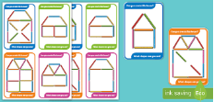 | Taught in provision  Construction area with various different construction toys, blocks play, duplo  Craft area with lots of different resources to use. Glue, scissors, tape…. | Taught in provision  Making a smiley face biscuit.  
Parent Engagement
Parents to be made aware of our focuses for EAD this half term in curriculum newsletter.
Provision Enhancements

Art (Expressive Arts and Design, Physical development, communication and language)

Exploring and Using Media and Materials  - To explore colour and how colours can be changed.  - To understand that they can use lines to enclose a space and then begin to use these shapes to represent objects.  - To begin to be interested in and describe the texture of things.  Being Imaginative  - To develop a preference for forms of expression.  - To notice what adults do, imitating what is observed and then doing it spontaneously when the adult is not there.  - To capture experiences and responses with a range of media, such as music, dance and paint and other materials or words. |  |  | Start to make marks intentionally.  Explore paint, using fingers and other parts of their bodies as well as brushes and other tools.  Express ideas and feelings through making marks, and sometimes give a meaning to the marks they make.
Possible activities in order to achieve progression of skills objectives for Autumn 1
Taught session and Taught in provision (links to maths and EAD)  Mixing colours | Taught session and Taught in provision (links to maths and EAD)  Colour shades | Taught Session  Drawing a picture of family | Taught Session  Self-portraits painted and drawn. | Taught Session  Drawing pets | Taught in provision  Large painting on easel (links to PD)
Parent Engagement
Parents to send in family photo through dojo. Information shared about how we will be using these to support the children’s learning.
Parents to be made aware of our focuses for EAD this half term in curriculum newsletter.
Provision Enhancements
Pictures of different famalies, pets, opportunities to mix colours and create different shades.

Music (EAD, PD, C&L)
Communication and Language  • Sing a large repertoire of songs.  Physical Development  • Use large-muscle movements to wave flags and streamers, paint and make marks.  Expressive Arts and Design  • Listen with increased attention to sounds.  • Respond to what they have heard, expressing their thoughts and feelings.  • Remember and sing entire songs.  • Sing the pitch of a tone sung by another person (‘pitch match’).  • Sing the melodic shape (moving melody, such as up and down, down and up) of familiar songs.  • Create their own songs, or improvise a song around one they know.  • Play instruments with increasing control to express their feelings and ideas. |  |  | Use voices expressively.  To find a singing voice and begin to use their voice confidently –  Sing echo songs and perform movements to a steady beat.  Explore singing fast and slow and changing speeds. Explore how to use the voice to create loud and quiet sounds.
Possible activities in order to achieve progression of skills objectives for Autumn 1
Taught Session  Number rhymes (links to maths) | Taught Session  Topic songs with actions. | Taught Session  Using musical instruments exploring loud and quiet. (links to phonics)  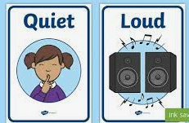 |  | Taught Session  Using musical instruments exploring fast and slow. (links to phonics)  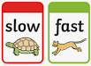 | Taught Session  Echo Songs. | Taught in provision  Musical Instruments with musical vocabulary flash cards. (fast, slow, loud, quiet.
Parent Engagement
Topic song sheets sent home. (links to literacy)

Provision Enhancements
Make laminated copies of all songs.
Loud and quiet signs
Fast and slow signs

ICT (UTW, EAD,C&L, PD)
Understanding the World – Technology and learning opportunities  - To know that information can be retrieved from computers.  - To show skill in making toys work by pressing parts or lifting flaps to achieve effects such as sound, movements or new images.  - To show an interest in technological toys with knobs or pulleys, or real objects.  - To know how to operate simple equipment |  | The World  Talk about the lives of the people around them and their roles in society.  Use videos/zoom to watch pre-recorded interviews with police etc. or live zoom.  Expressive arts and design  Listen to a variety of music and sounds recorded on a sound button or iPad.  Press buttons on noisy books to make sounds.
Possible activities in order to achieve progression of skills objectives for Autumn 1
Taught Session  Parents to dojo in family photo. Teacher to verbally talk through the process of accessing dojo to see the photos. Children to show an interest. | Taught in provision  Action response toys with buttons, lifting flaps, sounds  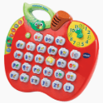  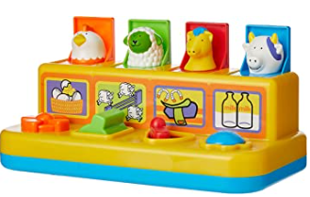 |  | Taught in provision  Interactive games on the whiteboard | Taught in provision  Ipads – Children to take photos and adult to support sending them directly to print.
Parent Engagement
Questionnaire sent home asking what access the children have to ICT.
Parents to send in family photo through dojo. Information shared about how we will be using these to support the children’s learning.
Provision Enhancements
Ict toys to be put on snack table once snack is finished.

