
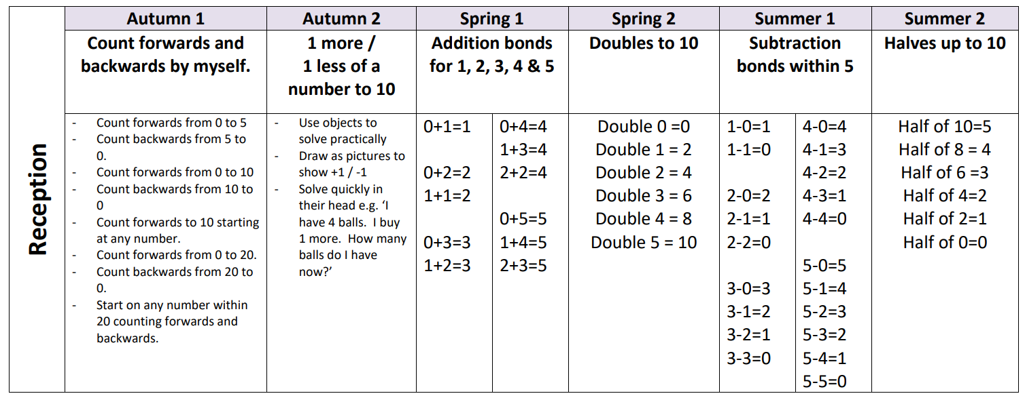
Progression in Maths fluency skills – key focus for half term
All of the above should be done practically and orally.

Progression in Maths fluency skills – key focus for half term
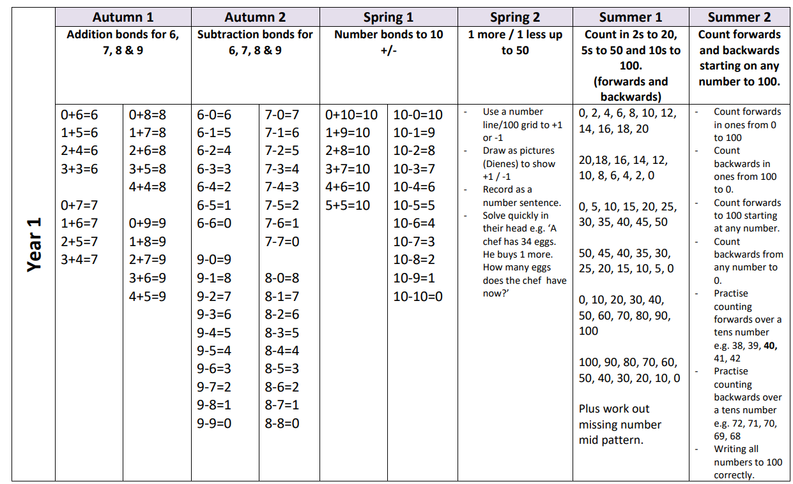
In Year 1, children should practise these orally (and practically) but should also aim to record as written number sentences or written counting patterns as part of Fast Maths
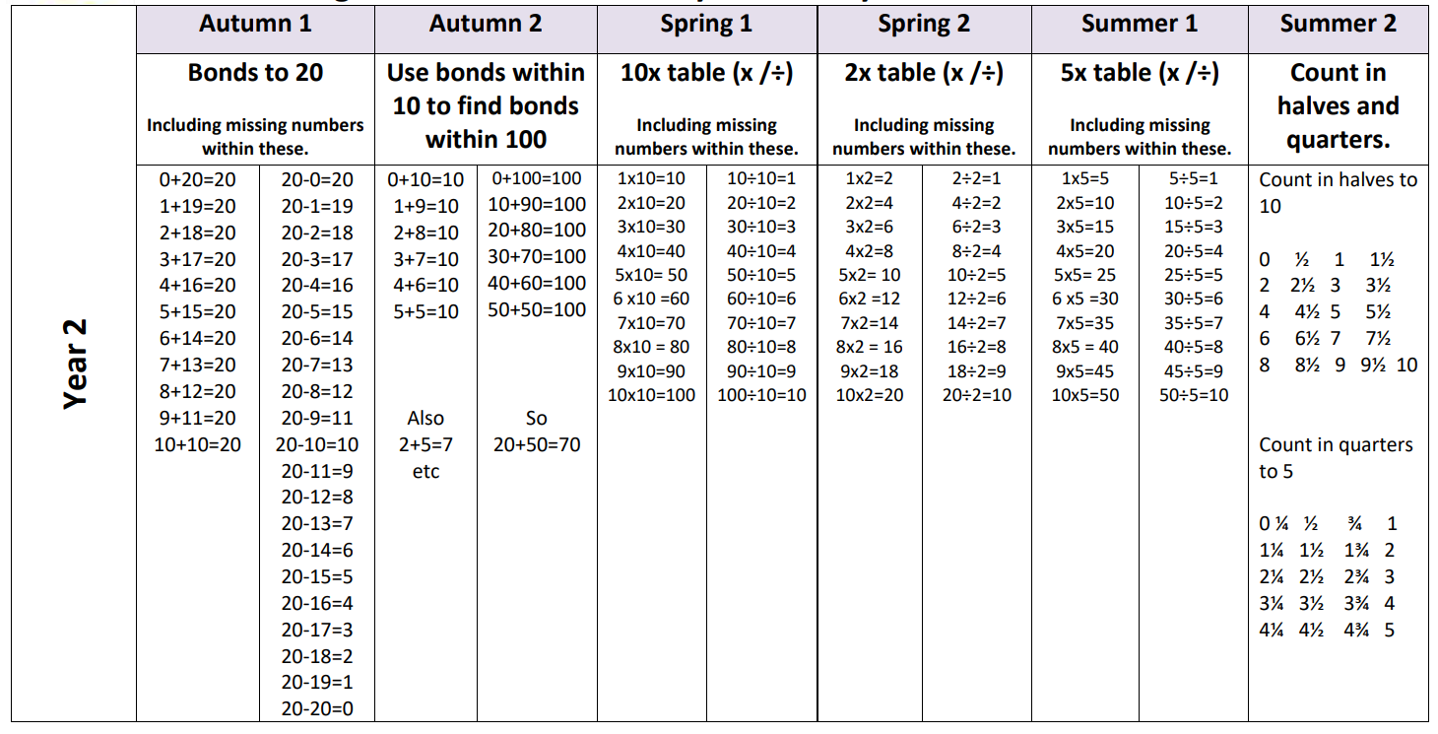
Progression in Maths fluency skills – key focus for half term
In Year 2, children should practise these orally (and practically) but should also aim to record as written number sentences or written counting patterns as part of Fast Maths

